Digital Nurture 4.0 – Week 4
Spring rest using spring boot

1: Create a spring web project using maven
- Go to https://start.spring.io/
- Change Group as “com.cognizant”
- Change Artifact Id as “spring-learn”
- Select Spring Boot DevTools and Spring Web
- Create and download the project as zip
- Extract the zip in root folder to Eclipse Workspace
- Build the project using ‘mvn clean package -Dhttp.proxyHost=proxy.cognizant.com -Dhttp.proxyPort=6050 -Dhttps.proxyHost=proxy.cognizant.com -Dhttps.proxyPort=6050 -Dhttp.proxyUser=123456’ command in command line
- Import the project in Eclipse "File > Import > Maven > Existing Maven Projects > Click Browse and select extracted folder > Finish"
- Include logs to verify if main() method of SpringLearnApplication.
Run the SpringLearnApplication class

SME to walk through the following aspects related to the project created:
- src/main/java - Folder with application code
- src/main/resources - Folder for application configuration
- src/test/java - Folder with code for testing the application
- SpringLearnApplication.java - Walkthrough the main() method.
- Purpose of @SpringBootApplication annotation
- pom.xml

PROGRAM
pom.xml
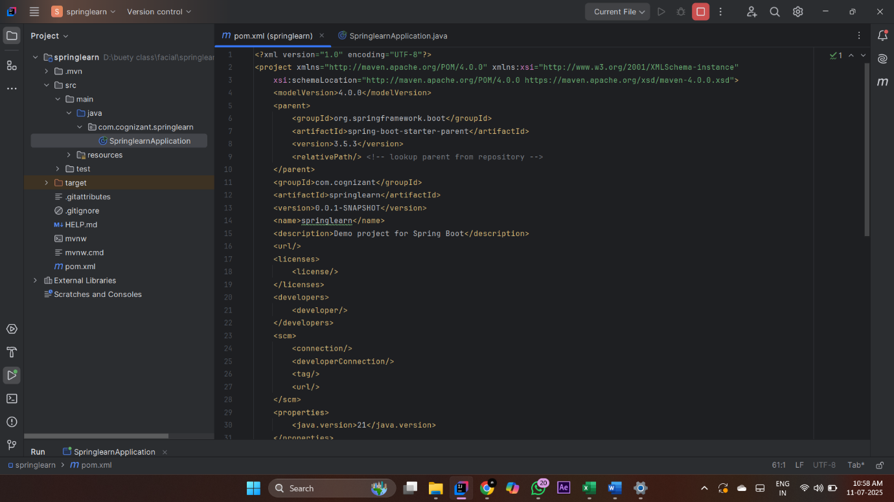

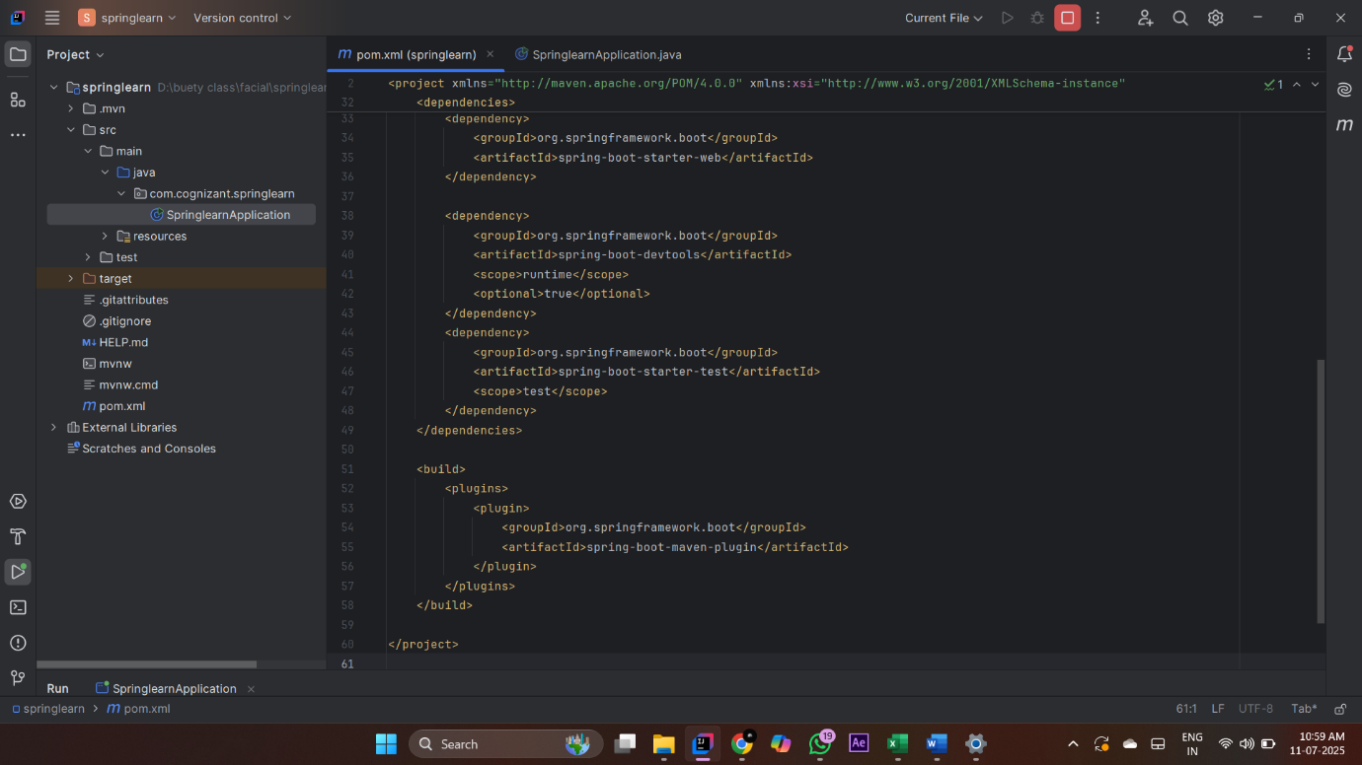

Springlearnapplication.java
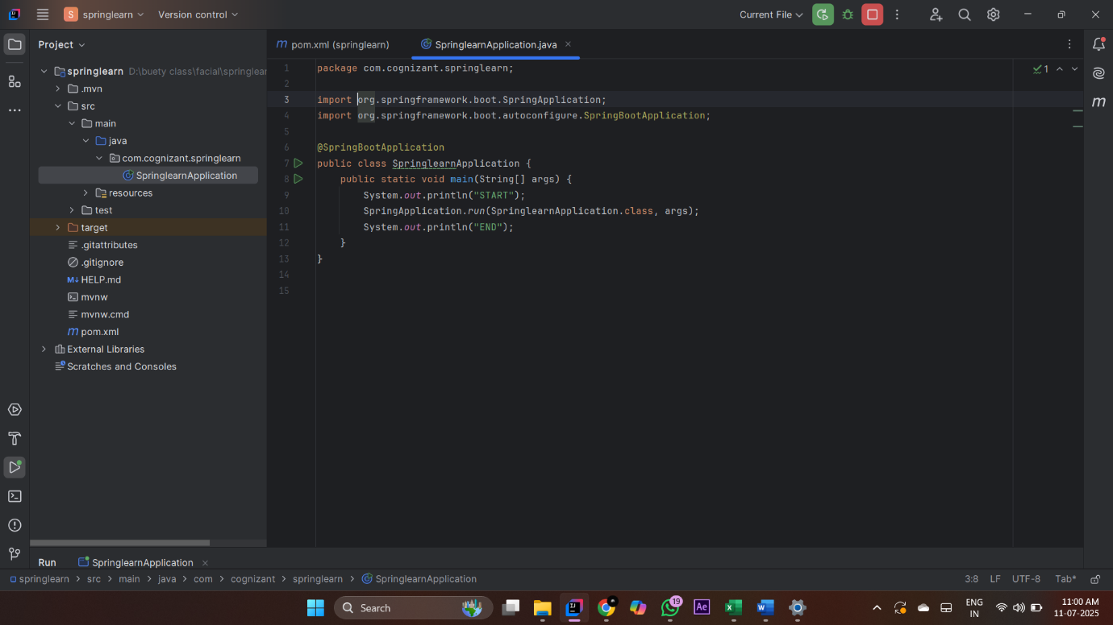

OUTPUT
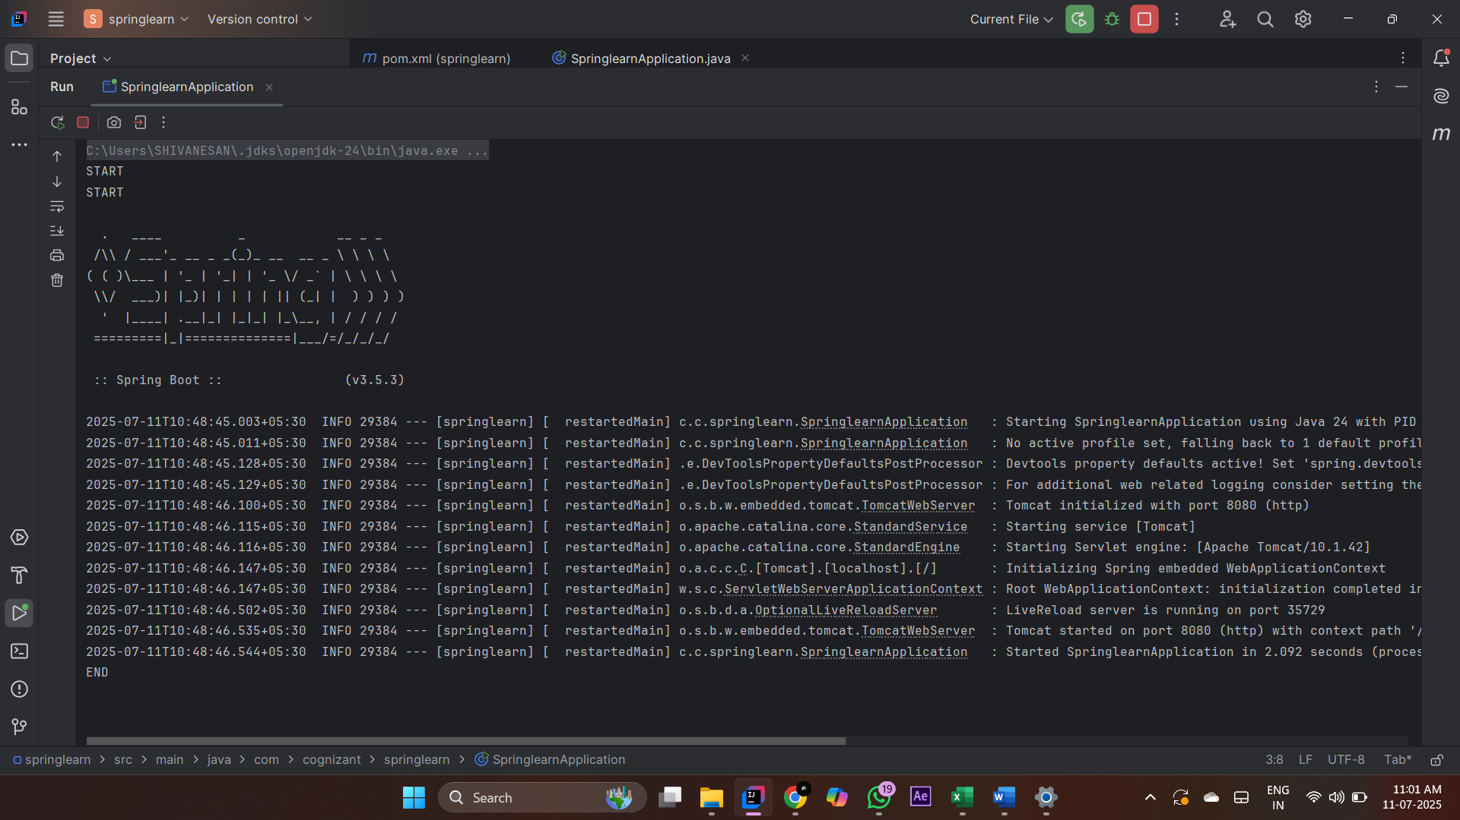

2.Spring Core – Load SimpleDateFormat from Spring Configuration XML
SimpleDateFormat with the pattern ‘dd/MM/yyyy’ is created in multiple places of an application. To avoid creation of SimpleDateFormat in multiple places, define a bean in Spring XML Configuration file and retrieve the date.
Follow steps below to implement:
- Create spring configuration file date-format.xml in src/main/resources folder of 'spring-learn' project
- Open https://docs.spring.io/spring-framework/docs/current/spring-framework-reference/core.html#beans-factory-metadata
- Copy the XML defined in the section of previous step URL and paste it into date-format.xml
- Define bean tag in the XML with for date format. Refer code below.

- Create new method displayDate() in SpringLearnApplication.java
- In displayDate() method create the ApplicationContext. Refer code below:
ApplicationContext context = new ClassPathXmlApplicationContext("date-format.xml");
- Get the dateFormat using getBean() method. Refer code below.
SimpleDateFormat format = context.getBean("dateFormat", SimpleDateFormat.class);
- Using the format variable try to parse string '31/12/2018' to Date class and display the result using System.out.println.
- Run the application as 'Java Application' and check the result in console log output.

PROGRAM
pom.xml
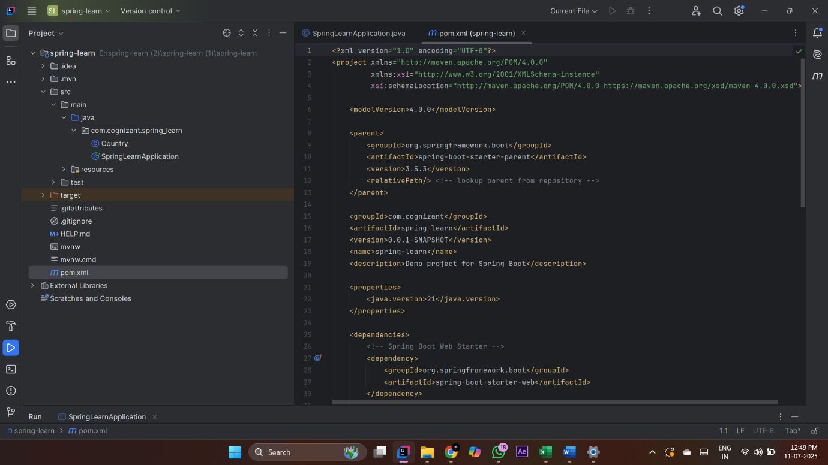

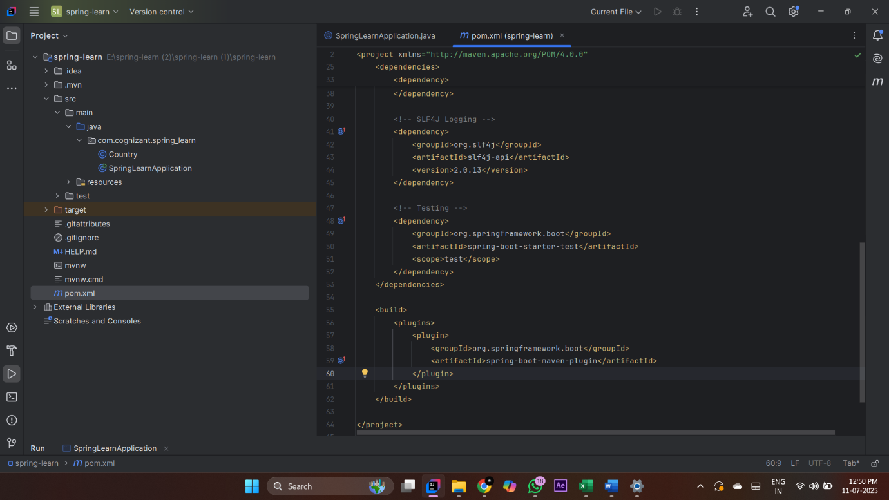

Country.java
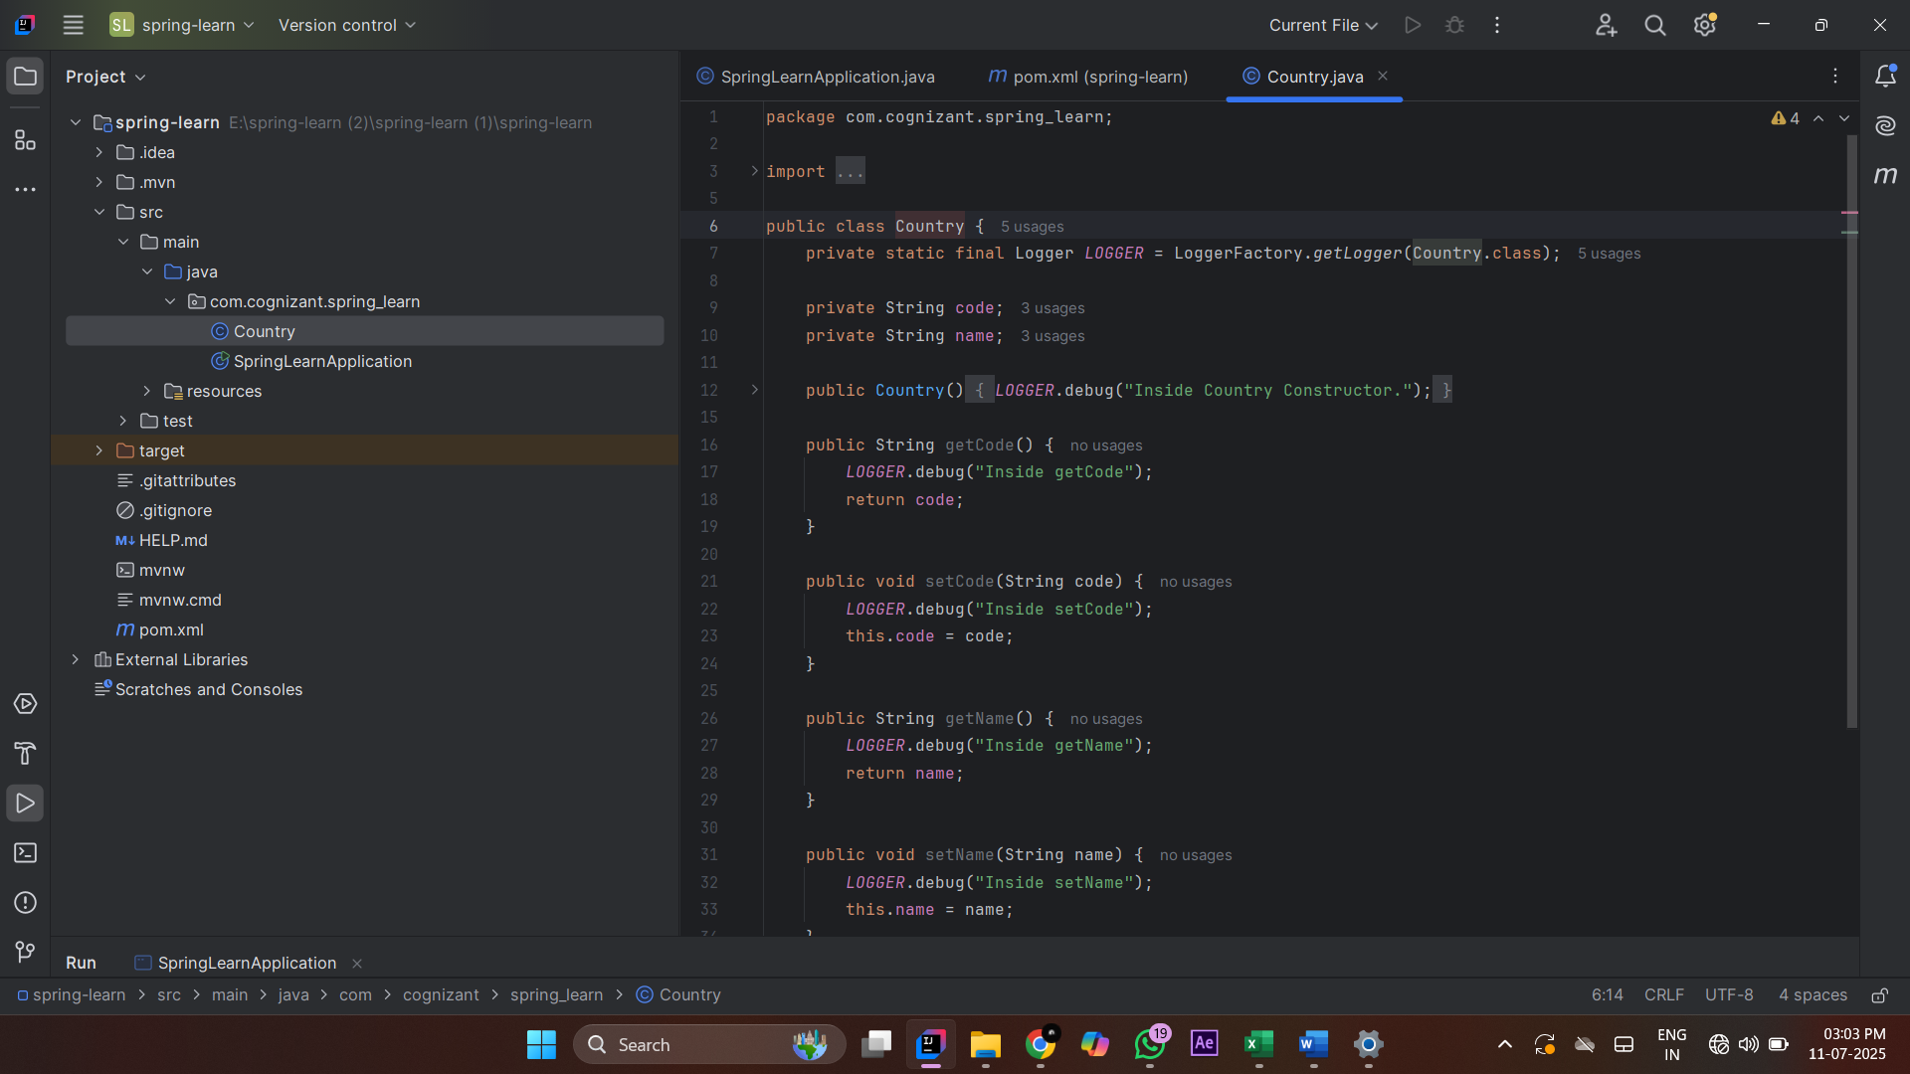

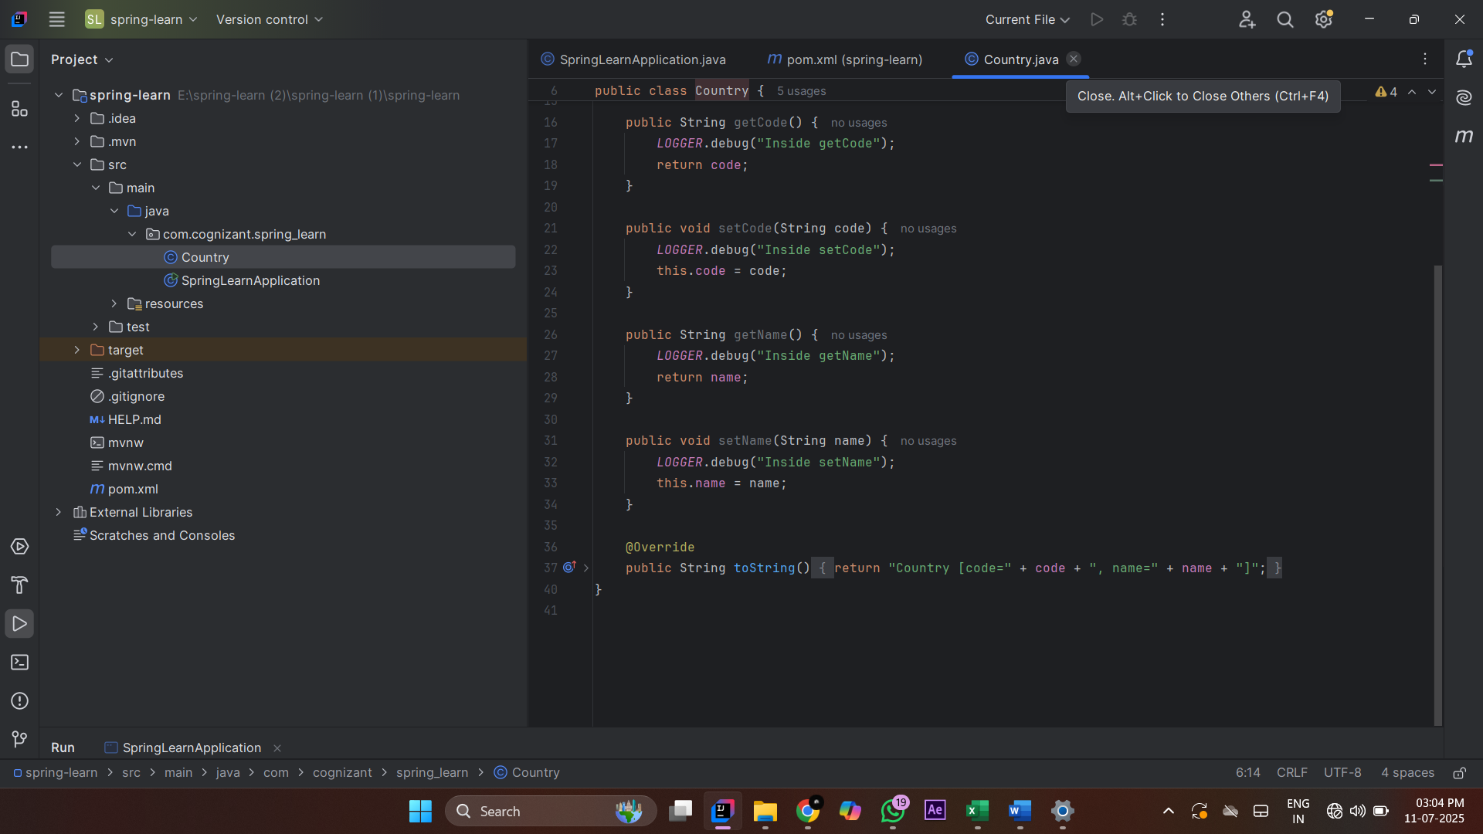

Springlearnapplication.java
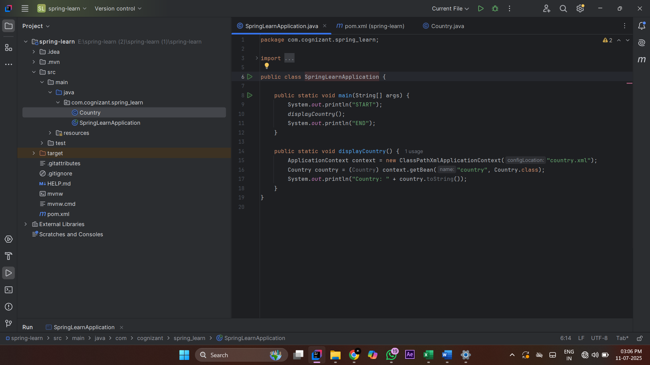

OUTPUT
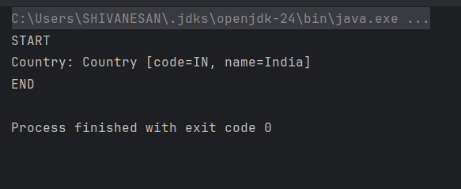

3: Helloworld RESTFUL webservice
Pom.xml:
<?xml version="1.0" encoding="UTF-8"?>
<project xmlns="http://maven.apache.org/POM/4.0.0"
xmlns:xsi="http://www.w3.org/2001/XMLSchema-instance"
xsi:schemaLocation="http://maven.apache.org/POM/4.0.0 https://maven.apache.org/xsd/maven-4.0.0.xsd">
<modelVersion>4.0.0</modelVersion>
<parent>
<groupId>org.springframework.boot</groupId>
<artifactId>spring-boot-starter-parent</artifactId>
<version>3.5.3</version>
<relativePath/> <!-- lookup parent from repository -->
</parent>
<groupId>com.cognizant</groupId>
<artifactId>spring-learn</artifactId>
<version>0.0.1-SNAPSHOT</version>
<name>spring-learn</name>
<description>Hello World RESTful Web Service Project</description>
<properties>
<java.version>21</java.version>
</properties>
<dependencies>
<!-- Spring Boot Web Starter -->
<dependency>
<groupId>org.springframework.boot</groupId>
<artifactId>spring-boot-starter-web</artifactId>
</dependency>
<!-- Spring Boot DevTools (for hot reload during development) -->
<dependency>
<groupId>org.springframework.boot</groupId>
<artifactId>spring-boot-devtools</artifactId>
<scope>runtime</scope>
<optional>true</optional>
</dependency>
<!-- Testing (optional) -->
<dependency>
<groupId>org.springframework.boot</groupId>
<artifactId>spring-boot-starter-test</artifactId>
<scope>test</scope>
</dependency>
</dependencies>
<build>
<plugins>
<!-- Spring Boot Maven Plugin -->
<plugin>
<groupId>org.springframework.boot</groupId>
<artifactId>spring-boot-maven-plugin</artifactId>
<version>3.5.3</version>
</plugin>
</plugins>
</build>
</project>

Java Class:

HelloController.java
package com.cognizant.Spirng_learner.controller;
import org.slf4j.Logger;
import org.slf4j.LoggerFactory;
import org.springframework.web.bind.annotation.GetMapping;
import org.springframework.web.bind.annotation.RestController;
@RestController
public class HelloController {
private static final Logger LOGGER = LoggerFactory.getLogger(HelloController.class);
@GetMapping("/hello")
public String sayHello() {
LOGGER.debug("START");
LOGGER.debug("END");
return "Hello World!!";
}
}

SpringlearnerApplication.java
package com.cognizant.Spirng_learner;
import org.springframework.boot.SpringApplication;
import org.springframework.boot.autoconfigure.SpringBootApplication;
@SpringBootApplication
public class SpringlearnerApplication {
public static void main(String[] args) {
SpringApplication.run(SpringlearnerApplication.class, args);
}
}

Application.properties:
spring.application.name=Springlearner
server.port=8083

OUTPUT:
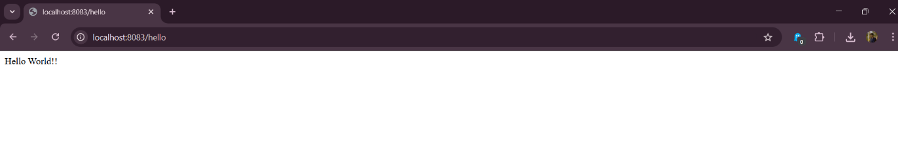

4 :PROJECT STRUCTURE
Pom.xml
<?xml version="1.0" encoding="UTF-8"?>
<project xmlns="http://maven.apache.org/POM/4.0.0"
xmlns:xsi="http://www.w3.org/2001/XMLSchema-instance"
xsi:schemaLocation="http://maven.apache.org/POM/4.0.0 https://maven.apache.org/xsd/maven-4.0.0.xsd">
<modelVersion>4.0.0</modelVersion>
<parent>
<groupId>org.springframework.boot</groupId>
<artifactId>spring-boot-starter-parent</artifactId>
<version>3.5.3</version>
<relativePath/> <!-- lookup parent from repository -->
</parent>
<groupId>com.cognizant</groupId>
<artifactId>spring-learn</artifactId>
<version>0.0.1-SNAPSHOT</version>
<name>spring-learn</name>
<description>Demo project for Spring Boot</description>
<properties>
<java.version>21</java.version>
</properties>
<dependencies>
<!-- Spring Boot Web Starter -->
<dependency>
<groupId>org.springframework.boot</groupId>
<artifactId>spring-boot-starter-web</artifactId>
</dependency>
<!-- Spring Boot DevTools -->
<dependency>
<groupId>org.springframework.boot</groupId>
<artifactId>spring-boot-devtools</artifactId>
<scope>runtime</scope>
<optional>true</optional>
</dependency>
<!-- SLF4J Logging -->
<dependency>
<groupId>org.slf4j</groupId>
<artifactId>slf4j-api</artifactId>
<version>2.0.13</version>
</dependency>
<!-- Testing -->
<dependency>
<groupId>org.springframework.boot</groupId>
<artifactId>spring-boot-starter-test</artifactId>
<scope>test</scope>
</dependency>
</dependencies>
<build>
<plugins>
<plugin>
<groupId>org.springframework.boot</groupId>
<artifactId>spring-boot-maven-plugin</artifactId>
</plugin>
</plugins>
</build>
</project>

Java class:
Package : controller
Class :CountryController
CountryController.java
package com.cognizant.spring_learn.controller;
import com.cognizant.spring_learn.model.Country;
import org.springframework.context.ApplicationContext;
import org.springframework.context.support.ClassPathXmlApplicationContext;
import org.springframework.web.bind.annotation.RequestMapping;
import org.springframework.web.bind.annotation.RestController;
@RestController
public class CountryController {
@RequestMapping("/country")
public Country getCountryIndia() {
ApplicationContext context = new ClassPathXmlApplicationContext("country.xml");
Country country = (Country) context.getBean("in");
return country;
}
}

Package : model
Class : Country
Country.java:
package com.cognizant.spring_learn.model;
import org.slf4j.Logger;
import org.slf4j.LoggerFactory;
public class Country {
private static final Logger LOGGER = LoggerFactory.getLogger(Country.class);
private String code;
private String name;
public Country() {
LOGGER.debug("Inside Country Constructor.");
}
public String getCode() {
LOGGER.debug("Inside getCode");
return code;
}
public void setCode(String code) {
LOGGER.debug("Inside setCode");
this.code = code;
}
public String getName() {
LOGGER.debug("Inside getName");
return name;
}
public void setName(String name) {
LOGGER.debug("Inside setName");
this.name = name;
}
@Override
public String toString() {
return "Country [code=" + code + ", name=" + name + "]";
}
}

SpringLearnApplication.java
package com.cognizant.spring_learn;
import com.cognizant.spring_learn.model.Country;
import org.springframework.context.ApplicationContext;
import org.springframework.context.support.ClassPathXmlApplicationContext;
public class SpringLearnApplication {
public static void main(String[] args) {
System.out.println("START");
displayCountry();
System.out.println("END");
}
public static void displayCountry() {
ApplicationContext context = new ClassPathXmlApplicationContext("country.xml");
Country country = (Country) context.getBean("in");
System.out.println("Country: " + country.toString());
}
}

Country.xml
<?xml version="1.0" encoding="UTF-8"?>
<beans xmlns="http://www.springframework.org/schema/beans"
xmlns:xsi="http://www.w3.org/2001/XMLSchema-instance"
xsi:schemaLocation="http://www.springframework.org/schema/beans
http://www.springframework.org/schema/beans/spring-beans.xsd">
<bean id="in" class="com.cognizant.spring_learn.model.Country">
<property name="code" value="IN"/>
<property name="name" value="India"/>
</bean>
</beans>
OUTPUT:
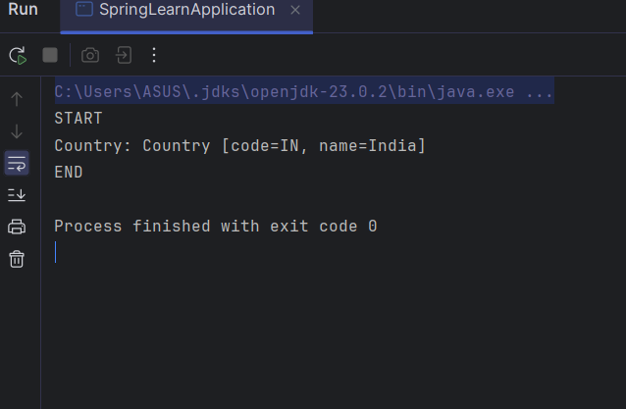

5: REST - Get country based on country code

Country.xml:
<?xml version="1.0" encoding="UTF-8"?>
<beans xmlns="http://www.springframework.org/schema/beans"
xmlns:xsi="http://www.w3.org/2001/XMLSchema-instance"
xsi:schemaLocation="http://www.springframework.org/schema/beans
https://www.springframework.org/schema/beans/spring-beans.xsd">
<bean id="countryList" class="java.util.ArrayList">
<constructor-arg>
<list>
<bean class="com.cognizant.spring_learn.model.Country">
<property name="code" value="IN"/>
<property name="name" value="India"/>
</bean>
<bean class="com.cognizant.spring_learn.model.Country">
<property name="code" value="US"/>
<property name="name" value="United States"/>
</bean>
<bean class="com.cognizant.spring_learn.model.Country">
<property name="code" value="JP"/>
<property name="name" value="Japan"/>
</bean>
</list>
</constructor-arg>
</bean>
</beans>

CountryService.java:
package com.cognizant.spring_learn.service;
import com.cognizant.spring_learn.model.Country;
import org.springframework.context.ApplicationContext;
import org.springframework.context.support.ClassPathXmlApplicationContext;
import org.springframework.stereotype.Service;
import java.util.List;
@Service
public class CountryService {
public Country getCountry(String code) {
ApplicationContext context = new ClassPathXmlApplicationContext("country.xml");
List<Country> countryList = context.getBean("countryList", List.class);
return countryList.stream()
.filter(country -> country.getCode().equalsIgnoreCase(code))
.findFirst()
.orElse(null);
}
}
CountryController.java:
package com.cognizant.spring_learn.controller;
import com.cognizant.spring_learn.model.Country;
import com.cognizant.spring_learn.service.CountryService;
import org.slf4j.Logger;
import org.slf4j.LoggerFactory;
import org.springframework.beans.factory.annotation.Autowired;
import org.springframework.context.ApplicationContext;
import org.springframework.context.support.ClassPathXmlApplicationContext;
import org.springframework.web.bind.annotation.*;
@RestController
public class CountryController {
private static final Logger LOGGER = LoggerFactory.getLogger(CountryController.class);
@Autowired
private CountryService countryService;
@RequestMapping("/country")
public Country getCountryIndia() {
LOGGER.info("START");
ApplicationContext context = new ClassPathXmlApplicationContext("country.xml");
Country country = context.getBean("in", Country.class);
LOGGER.info("END");
return country;
}
@GetMapping("/countries/{code}")
public Country getCountry(@PathVariable String code) {
LOGGER.info("START");
Country country = countryService.getCountry(code);
LOGGER.info("END");
return country;
}
}.

Output:
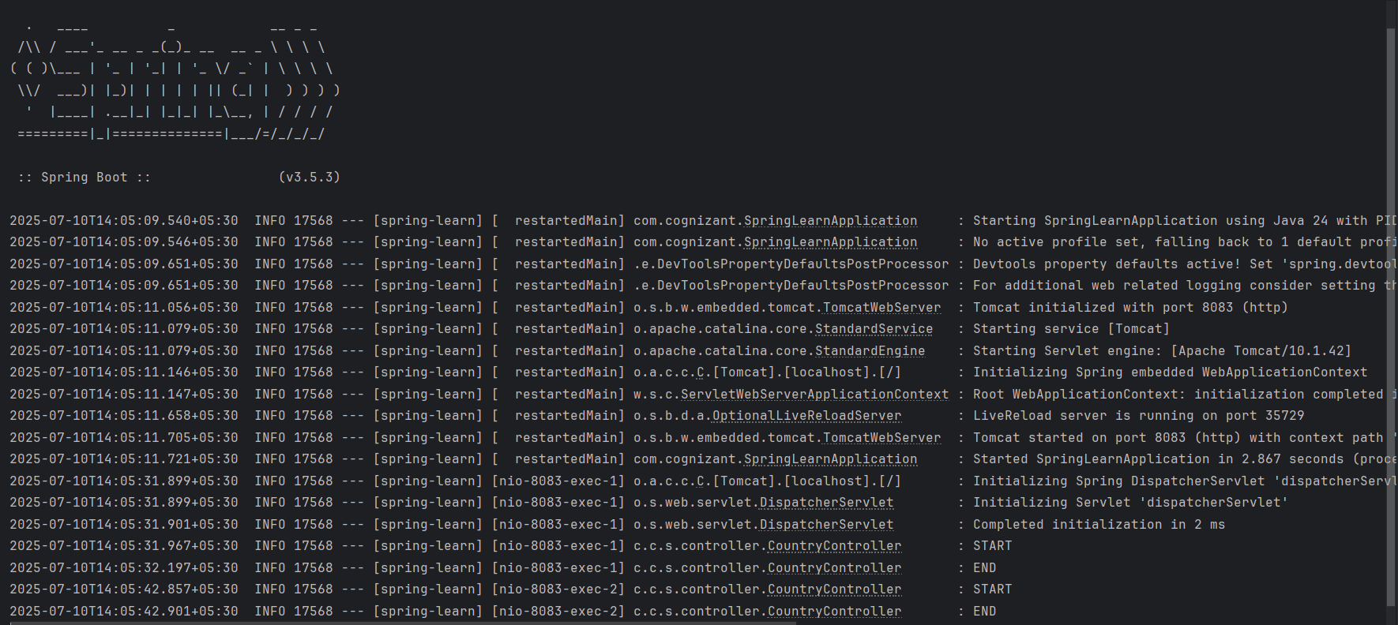
In browser:
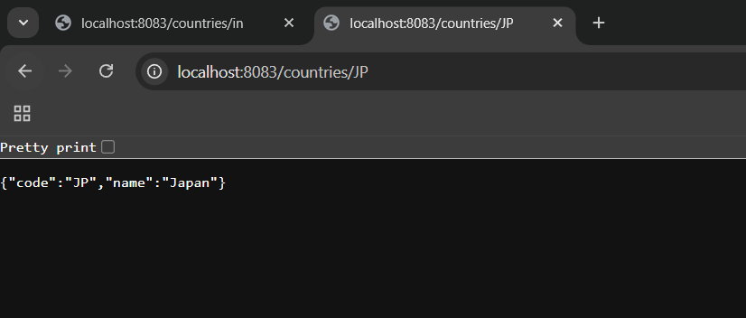

Exersice 6: Create authentication service that returns JWT
Pom.xml:
<?xml version="1.0" encoding="UTF-8"?>
<project xmlns="http://maven.apache.org/POM/4.0.0"
xmlns:xsi="http://www.w3.org/2001/XMLSchema-instance"
xsi:schemaLocation="http://maven.apache.org/POM/4.0.0 https://maven.apache.org/xsd/maven-4.0.0.xsd">
<modelVersion>4.0.0</modelVersion>
<parent>
<groupId>org.springframework.boot</groupId>
<artifactId>spring-boot-starter-parent</artifactId>
<version>3.5.3</version>
<relativePath/>
</parent>
<groupId>com.cognizant</groupId>
<artifactId>jwt-auth</artifactId>
<version>0.0.1-SNAPSHOT</version>
<name>jwt-auth</name>
<description>JWT Auth Project</description>
<properties>
<java.version>24</java.version>
</properties>
<dependencies>
<!-- Spring Boot Web and Security -->
<dependency>
<groupId>org.springframework.boot</groupId>
<artifactId>spring-boot-starter-web</artifactId>
</dependency>
<dependency>
<groupId>org.springframework.boot</groupId>
<artifactId>spring-boot-starter-security</artifactId>
</dependency>
<!-- JSON Web Token - JJWT -->
<dependency>
<groupId>io.jsonwebtoken</groupId>
<artifactId>jjwt-api</artifactId>
<version>0.11.5</version>
</dependency>
<dependency>
<groupId>io.jsonwebtoken</groupId>
<artifactId>jjwt-impl</artifactId>
<version>0.11.5</version>
<scope>runtime</scope>
</dependency>
<dependency>
<groupId>io.jsonwebtoken</groupId>
<artifactId>jjwt-jackson</artifactId>
<version>0.11.5</version>
<scope>runtime</scope>
</dependency>
<!-- Servlet API -->
<dependency>
<groupId>jakarta.servlet</groupId>
<artifactId>jakarta.servlet-api</artifactId>
<version>6.0.0</version>
<scope>provided</scope>
</dependency>
<!-- Development and Testing -->
<dependency>
<groupId>org.springframework.boot</groupId>
<artifactId>spring-boot-devtools</artifactId>
<scope>runtime</scope>
<optional>true</optional>
</dependency>
<dependency>
<groupId>org.springframework.boot</groupId>
<artifactId>spring-boot-starter-test</artifactId>
<scope>test</scope>
</dependency>
<dependency>
<groupId>org.springframework.security</groupId>
<artifactId>spring-security-test</artifactId>
<scope>test</scope>
</dependency>
</dependencies>
<build>
<plugins>
<plugin>
<groupId>org.springframework.boot</groupId>
<artifactId>spring-boot-maven-plugin</artifactId>
</plugin>
</plugins>
</build>
</project>
- Create package named jwt_auth and config,controller
- Path src/main/java/com/cognizant/jwt_auth/controller, src/main/java/com/cognizant/jwt_auth/config.
- Then create a class named AuthenticationController.java in src/main/java/com/cognizant/jwt_auth/controller/AuthenticationController.java.

AuthenticationController.java:
package com.cognizant.jwt_auth.controller;
import io.jsonwebtoken.Jwts;
import io.jsonwebtoken.SignatureAlgorithm;
import io.jsonwebtoken.security.Keys;
import org.springframework.web.bind.annotation.GetMapping;
import org.springframework.web.bind.annotation.RestController;
import jakarta.servlet.http.HttpServletRequest;
import java.security.Key;
import java.util.Base64;
import java.util.Date;
import java.util.HashMap;
import java.util.Map;
@RestController
public class AuthenticationController {
private final Key secretKey = Keys.hmacShaKeyFor("ThisIsASecretKeyThatIsAtLeast32Chars!".getBytes());
@GetMapping("/authenticate")
public Map<String, String> authenticate(HttpServletRequest request) {
String authHeader = request.getHeader("Authorization");
if (authHeader == null || !authHeader.startsWith("Basic ")) {
throw new RuntimeException("Missing or invalid Authorization header");
}
String base64Credentials = authHeader.substring("Basic ".length());
String credentials = new String(Base64.getDecoder().decode(base64Credentials));
String[] values = credentials.split(":", 2);
String username = values[0];
String password = values[1];
if (!username.equals("user") || !password.equals("pwd")) {
throw new RuntimeException("Invalid credentials");
}
String token = Jwts.builder()
.setSubject(username)
.setIssuedAt(new Date())
.setExpiration(new Date(System.currentTimeMillis() + 600000)) // 10 minutes
.signWith(secretKey, SignatureAlgorithm.HS256)
.compact();
Map<String, String> response = new HashMap<>();
response.put("token", token);
return response;
}
}

SecurityConfig.java:
package com.cognizant.jwt_auth.config;
import org.springframework.context.annotation.Bean;
import org.springframework.context.annotation.Configuration;
import org.springframework.security.config.annotation.web.builders.HttpSecurity;
import org.springframework.security.config.annotation.web.configuration.EnableWebSecurity;
import org.springframework.security.core.userdetails.User;
import org.springframework.security.core.userdetails.UserDetails;
import org.springframework.security.core.userdetails.UserDetailsService;
import org.springframework.security.provisioning.InMemoryUserDetailsManager;
import org.springframework.security.web.SecurityFilterChain;
@Configuration
@EnableWebSecurity
public class SecurityConfig {
@Bean
public UserDetailsService userDetailsService() {
UserDetails user = User
.withUsername("user")
.password("{noop}pwd") // {noop} means no encoding
.roles("USER")
.build();
return new InMemoryUserDetailsManager(user);
}
@Bean
public SecurityFilterChain filterChain(HttpSecurity http) throws Exception {
http.csrf(csrf -> csrf.disable())
.authorizeHttpRequests(auth -> auth
.requestMatchers("/authenticate").authenticated()
.anyRequest().permitAll()
)
.httpBasic(); // enables basic auth
return http.build();
}
}

Application.properties:
spring.application.name=jwt-auth
server.port=8080

JwtAuthApplication.java:
package com.cognizant.jwt_auth;
import org.springframework.boot.SpringApplication;
import org.springframework.boot.autoconfigure.SpringBootApplication;
@SpringBootApplication
public class JwtAuthApplication {
public static void main(String[] args) {
SpringApplication.run(JwtAuthApplication.class, args);
}
}Output:
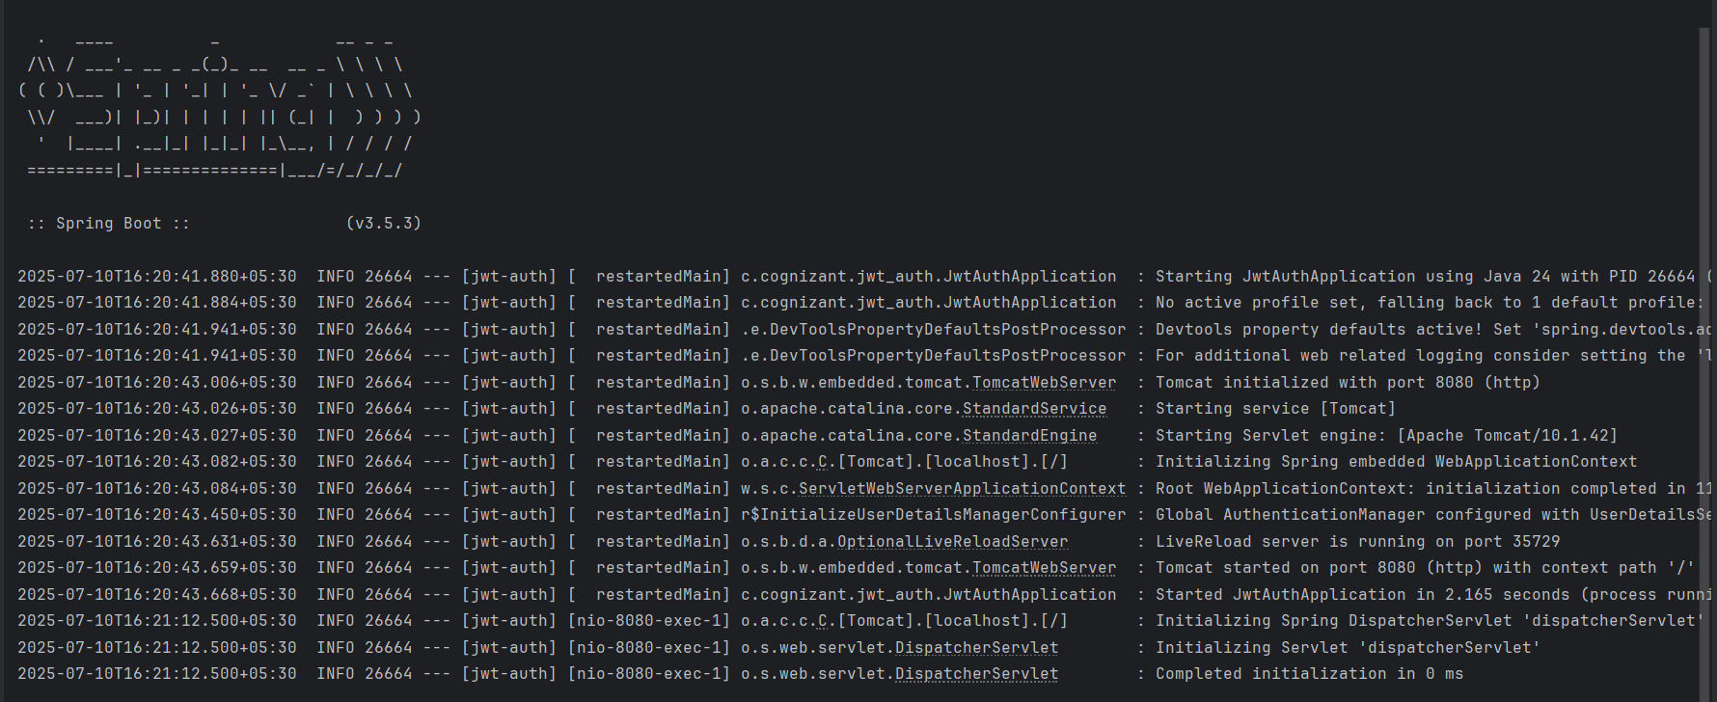

The terminal token generation:

